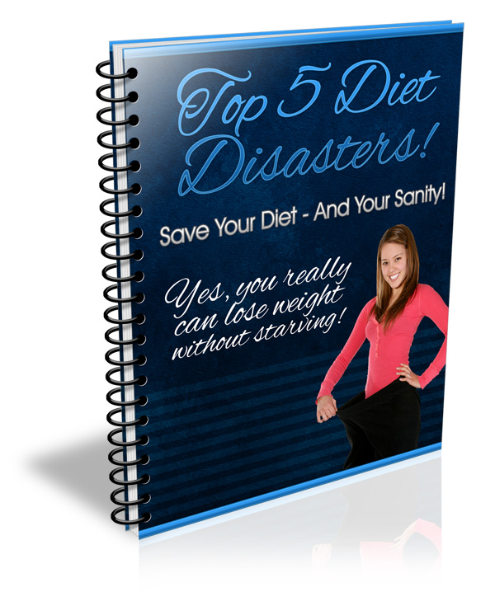
This Report Has Been Brought To You By:

www.YourDomain.com

TABLE OF CONTENTS
INTRODUCTION 3
EMOTIONAL EATING 3
PMS 5
CRAVINGS 6
ILLNESS 8
EATING TOO LITTLE 9
Healthy Foods 11

INTRODUCTION

Sticking to a diet is never easy, but there are a few key things that can derail a diet and send you spiraling out of control. Knowing these common issues can help you plan ahead. If you recognize these problems before they hit, you will be able to get them under control more easily.

One major key to success on any diet is your ability to stay focused and motivated, and to deal with any snags that come along. Dealing with those snags requires you to anticipate them, and to know what to do when they hit.

In this report, we’re going to discuss the 5 biggest diet snags that can lead to total disaster, as well as what you can do to avoid them, or to minimize the damage when they strike.

EMOTIONAL EATING

Perhaps the most damaging diet disaster is when emotional eating strikes. Emotional eating can be devastating to a diet, because it’s very hard to control once it starts.

You’ve heard the term “comfort food”, right? It’s a term used for foods that make us feel better when we’re depressed, angry, frustrated, or otherwise emotionally down.

These are usually fattening foods like meatloaf, mashed potatoes, lasagna, fried chicken, and other high-fat, high-calorie foods that tend to make us feel comfort during stressful times.

These foods can also spell disaster for a diet. They are usually high in carbohydrates that can cause the blood sugar to spiral out of control. This can lead to overeating, and it can be very difficult to stop once it starts.

Most people fall victim to emotional eating from time to time, but some people are far more susceptible than others. People who suffer from depression or have very stressful jobs are often victims of emotional eating.

Without a proper support network in place, emotional eating can be nearly impossible to control. You need to make sure you have friends, family, coworkers, a support group, or other network of people to help you get through your emotional issues.

You also have to learn to recognize when you’re truly hungry, and when you just want to eat to fill some emotional void. If you are having emotional issues that are making you want to eat, you need to contact someone in your support network.

Once you’ve learned to recognize true hunger, it will be easier to curb your emotional eating. You will be able to stop emotional eating sprees before they start, when it’s much easier to control them.

Once you give in and indulge, the cravings can spiral out of control. It can be very difficult to rein them in. But stopping them BEFORE they start is much easier.

PMS

Women will undoubtedly understand just how much premenstrual syndrome can affect the appetite. When the body is preparing for menstruation, it may start to crave certain things.

Sometimes this can be something that has a legitimate purpose, such as craving red meat or beans, which contain iron that can help replenish the blood that is about to be lost.

Other times, this can be high-carbohydrate, high-fat foods like ice cream, chocolate, cookies, candy, pizza, French fries, potato chips, and other fatty foods.

PMS can also cause depression and other emotional imbalances that can lead to emotional eating. These are actually quite common with PMS, and there’s not a lot you can do about it.
Whenever PMS strikes, your best bet is to proceed as you would with emotional eating. Call on your support network as much as possible. They will be able to help you through it.

You should also give into your cravings if you think you can keep them under control. A couple of squares of chocolate can help you weather the storm, but only if you can be sure you won’t go overboard.

If you are certain you can keep your cravings under control, it’s okay to have a small piece of cake, a bowl of ice cream, or a couple of slices of pizza during PMS.

CRAVINGS

Cravings can happen for a variety of reasons. Sometimes they can be caused by things like PMS and depression, but other times they may actually have roots in necessity.

Sometimes when you crave certain foods, it can have a physiological purpose. For example, if you’re craving things like spaghetti, lasagna, and pizza, it may actually be something like tomatoes you’re craving. Your body might be in need of something contained in tomatoes – a vitamin or perhaps an antioxidant like lycopene.

Sometimes you can be relatively certain your body isn’t craving anything for a reason. For example, sugar cookies are pretty much devoid of all nutritional value, so it’s unlikely your body would actually need anything that they contain.

Other times, it may be very difficult to figure out whether your body is actually craving something for a reason or just because you want the flavor of the food.

If you’re craving something that you think might have a nutritional foundation, try breaking down that food’s ingredients to figure out what it might be.

If you’re craving strawberry shortcake, the only nutritionally sound potential ingredient would be the strawberries themselves. It might be possible that you could be craving the calcium from the whipped cream, but that’s pretty unlikely, especially since it is often non-dairy.

If you have a craving for strawberry shortcake, try having some strawberries, perhaps with a bit of low-calorie whipped topping. This might satisfy your nutritional needs, if present, but it may also satisfy any flavor craving.

There are almost always alternatives you can choose that will contain the same base ingredients, but presented in a much healthier way. For example, you could have some spaghetti sauce with no pasta (or whole wheat pasta) for a spaghetti craving. You could have a slice of cheese for a grilled cheese sandwich craving.

Whenever you manage to cut a craving down by having the main base ingredient, you can be sure it was probably a physiological craving. If the craving continues, it is probably just a psychological craving because you want to taste the food.

That doesn’t mean you can’t satisfy a psychological craving now and then. Having a little bit of the stuff you crave can keep you happy and continuing on your diet. Just don’t overdo it.

You have to learn how to limit the foods you eat. If you can learn how to be careful and not let the cravings take you over, you can indulge on occasion.

ILLNESS

Whenever you’re sick, it can be harder than normal to stick to a diet. When you feel weak and sick, dieting is usually the last thing on your mind. Plus, your body needs extra nutrition to make it stronger.

While illness often makes it so you don’t feel hungry at all, it’s very important to eat to keep up your strength. You need to feed you immune system with plenty of vitamins and minerals to keep it working well.

But you must eat healthy foods, not junk. You may be feeling tired and depressed, but it’s important to make sure the food you do eat is the highest quality possible.

When you are feeling really poorly, eat lighter foods and liquids like broth, light soups, fruit, and juices. These are mostly low in fat and calories and can give you energy without making you feel tired.

When you feel a bit better, eat heartier, but bland foods like whole wheat toast, brown rice, steamed or roasted vegetables, and heartier soups.

You should stick with your general diet plan, but make sure you don’t eat anything that could make you feel worse. It’s best to avoid meats when you’re sick, because meat has the potential to harbor bacteria that could attack you when your immune system is weakened.

Illness can certainly derail your diet if you let it. Be sure you keep your strength up by eating plenty of healthy food. If you let your body weaken because you don’t eat enough, you will start experiencing cravings that you may satisfy with junk food. Not only could this harm your diet, but it could cause your immune system to weaken and it could take even longer to heal.

If your doctor has specific instructions for what you should eat, you should follow his or her instructions. Don’t worry about your diet if the instructions go against it. Your health is more important than the diet! You can always go back on your diet once your healthcare providers says it’s ok to do so.

EATING TOO LITTLE

Surprisingly one of the biggest problems dieters face is actually eating too little! When you eat too little, your body goes into a kind of “starvation mode” in which it slows the metabolism down to conserve precious body fat.
The body thinks it is starving, and that famine is imminent. Naturally, its instinct is to preserve body fat in case food has become scarce. So you have to convince your body there is plenty of food.

That means you have to eat plenty of food, and often. Skipping meals will leave you hungry and cranky, and you will be more likely to start craving things. Plus, it will slow your metabolism down immensely.

You must keep your metabolism up at all times, and that means eating often. That, of course, means eating healthy foods that are low enough in calories that you can eat them in quantity and often.

You should:
- Eat every 2-4 hours.
- Eat smaller meals of 200-400 calories each.
- Eat plenty of low calorie fruits and vegetables.
- Stick to whole grains.
- Don’t eat much sugar.
- Never skip meals.

You should keep a list of “safe foods” with you that you are allowed to have in unlimited quantities. Either memorize a list of 10-20 foods or carry it with you everywhere you go. This will help you grab a snack any time you want one without feeling guilty.

Healthy Foods

Apples  Pears  Plums  Peaches  Berries (all kinds)  Mangoes  Cherries  Cantaloupe  Honeydew Melons  Watermelon  Grapes  Nectarines | Carrots  Lettuce  Radishes  Cauliflower  Broccoli  Celery  Cucumbers  Spinach  Other Greens  Snow Peas  Tomatoes  Peppers

Make sure you always have some of these foods on hand, and I would advise you to prepare them well in advance. I like to prep my vegetables when I first bring them home. I take off tops, peel them, cut them up, and put them into plastic storage containers in the refrigerator so I can just grab them when I need them.

I find that one cause of me eating junk food is when I’m hungry and I don’t have anything prepared. Sometimes I feel a bit lazy or tired and I just want to grab something and eat. If I have to spend 10 minutes prepping salad ingredients, I will just eat chips!

By keeping a supply of these foods on hand to just grab whenever I’m hungry, I’m much more likely to take something that is truly healthy rather than grabbing junk because it’s convenient.
To a thinner, healthier you!
Your Name
Your Domain

